APPENDIX A: SITE INSPECTION CHECKLIST (NULINSPECTIE)
Project: Simonshaven DP2-4 (Nulinspectie)
Date 10 December 2025
Inspector: DNV – PJ Schutte

Evidence Mapping (Source: 01350-01-00075)
1. CDG - Roxtec Frames (Checklist A1)
Report Finding: Page 18, Finding 7 ("EM/LPZ zonering CDG")
Text: "Het EMC invoerraam in de AC ruimte lijkt niet consistent te zijn toegepast. Er zijn geen aardverbindingen vanaf het frame... zichtbaar." (The EMC frame in the AC room... no earth connections visible from the frame).
Photo: Page 33, PH2-7231.
2. CDG - Wall Penetrations (Checklist A2)
Report Finding: Page 18, Finding 8 ("EM/ LPZ zonering apparatuur ruimten")
Text: "Ook zijn er in de VBS ruimte diverse boringen in de muren waar leidingen en kabels zonder EMC maatregel worden doorgevoerd." (Various borings in walls where pipes/cables pass without EMC measures).
Photo: Page 37, PH19-7255 (Shows pipes/cables going through the wall).
3. CDG - Cabinet Earthing "Pigtails" (Checklist A3)
Report Finding: Page 18, Finding 6 ("Aarding apparatuur kasten")
Text: "...is de kast geaard d.m.v. VD50mm2 via de kastinvoer/brievenbus (PH32-7272)." (Cabinet earthed via round wire [VD50mm2]...).
Photo: Page 40, PH32-7272 (Look at the right side of the photo, the green/yellow wire).
4. Takhuisjes - Plastic Glands (Checklist B1)
Report Finding: Page 21, Finding 9 ("EMC maatregelen voedingskabels")
Text: "...maar met kunststof wartels (PH29-7268 en PH30-7269)." (...but with plastic glands).
Photo: Page 39, PH29-7268 (Shows the grey cables entering through white plastic glands).
5. Takhuisjes - Wall Earth Bar (Checklist B2)
Report Finding: Page 20, Finding 5 ("Uitvoering EMC-net")
Text: "Binnen de takhuisjes zijn geen verbindingen met het separaat aangebrachte EMC-net aangetroffen." (Inside bay houses, no connections to the EMC mesh found).
Photo: Page 42, PH41-7292 (Shows the copper bar on the wall; check if it connects to the concrete).
6. Takhuisjes - Missing PEC (Checklist B3)
Report Finding: Page 20, Finding 4 ("PEC’s van buiten naar binnen")
Text: "Aan de veldzijde is bij takhuisje 3 geen PEC gevonden." (At field side bay house 3, no PEC found).
Photo: Page 42, PH45-7291.
7. Trenches - Missing PEC (Checklist C1)
Report Finding: Page 17, Finding 4 ("PEC’s van buiten naar binnen")
Text: "Er is geen aardverbinding/PEC vanuit de kabelbak/goot van buiten naar binnen aangetroffen." (No earth connection/PEC from cable tray outside to inside found).
Photo: None in report (This is why you must take one).

- 1. CENTRAL SERVICE BUILDING (CDG)
Location: AC Room, DC Room, Telecom Room
ID | Item | What to Look For (The Defect) | Reference Photo (Paste from PDF 1) | Status (OK/NOK)
A1 | Roxtec Frames (AC Room) | Defect: "Inconsistent application." No visible earth wire from the metal frame to the earth bar.Check: Is the frame bonded? | Paste Photo PH2-7231(Page 33)Shows blue blocks, check frame edge for earth wire.
A2 | Cable Penetrations (VBS Room) | Defect: Cables/Pipes entering through drilled holes without EMC glands or frames.Check: Are these holes still open? | Paste Photo PH19-7255(Page 37)Shows pipes/cables passing through ceiling/wall.
A3 | Cabinet Earthing (VBS/Telecom) | Defect: Use of long, round green/yellow wires ("Pigtails") instead of short, flat braids (Litze).Check: Has this been retrofitted to flat braid? | Paste Photo PH32-7272(Page 40)Shows long green/yellow wire on right side.
A4 | Computer Floor (VBS) | Defect: Unclear bonding of the floor grid.Check: Look under the floor tiles. Is the pedestal grid connected to the ring earth? | Paste Photo PH7-7237(Page 34)Shows floor pedestals.
- 2. BAY HOUSES (TAKHUISJES)
Location: The small buildings in the field (Tak 1, Tak 2, etc.)
ID | Item | What to Look For (The Defect) | Reference Photo (Paste from PDF 1) | Status (OK/NOK)
B1 | AC/DC Distribution Cabinets | Defect: MAJOR ISSUE. Plastic glands used instead of metal EMC glands.Check: Look at the bottom of the AC/DC cabinets. Are the glands grey (plastic) or metal? | Paste Photo PH29-7268(Page 39)Shows grey cables entering via plastic glands.
B2 | Wall Earth Bar (Aardrail) | Defect: No visible connection to the wall reinforcement (EMC Mesh).Check: Follow the copper bar on the wall. Does it have taps going into the concrete wall? | Paste Photo PH41-7292(Page 42)Shows the copper bar running along the wall.
B3 | Floor Entry Takhuisje 3(PEC) | Defect: PEC (Parallel Earth Conductor) status is not found.Check: Look at the floor entry. Do you see a thick copper wire (PEC) coming from the outside trench and connecting to the earth bar?  Check cable trenches | Paste Photo PH45-7291(Page 42)Shows the floor entry point.
- 3. OUTDOOR / TRENCHES (BUITENTERREIN)
Location: Cable trenches and field assets
ID | Item | What to Look For (The Defect) | Reference Photo (Paste from PDF 1) | Status (OK/NOK)
C1 | Trench PEC (The "Missing Link") | Defect: Report states PECs were missing in some sections.Check: ACTION: Lift a trench cover near the CDG. Is there a copper wire running parallel to the cables? Takhuisje 3 | NO PHOTO IN REPORT(You must take this photo)
C2 | Portal Earthing | Check: Verify steel portals have 2x diagonal earth connections. | Paste Photo PH49-7300(Page 43)Shows portal leg earthing.
C3 | Fence Earthing (Hekwerk) | Check: Are fence panels bonded with flexible straps? | Paste Photo PH58-CDG1(Page 45)Shows fence detail.
- 4. DP2-4 INTEGRATION (NEW SCOPE)
Location: Future location of Transformers & Bays 4-5
ID | Item | What to Look For | Status
D1 | Spare Roxtec Frames | Identify the specific spare frames in the CDG wall allocated for DP2-4. Are they earthed?
D2 | New Earth Risers (Opstekers) | Locate the earth points in the field where the new DP2-4 equipment will connect. Are they visible and in good condition?

A1 – AC ruimte | A2 Telecomruimte
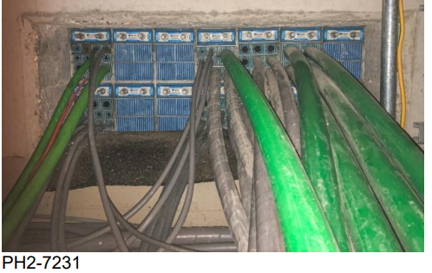 | 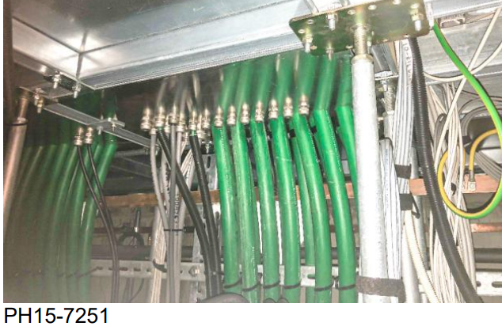
A3 – Telecomruimte | A4 – VBS ruimte
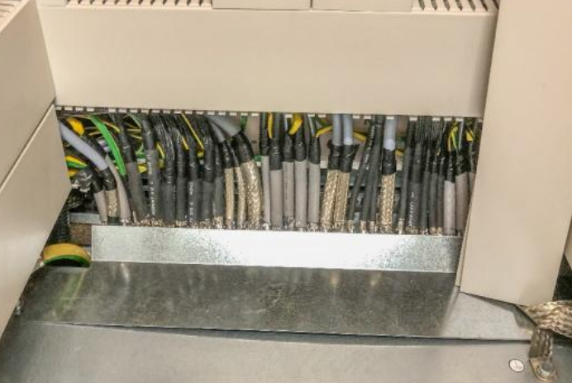 | 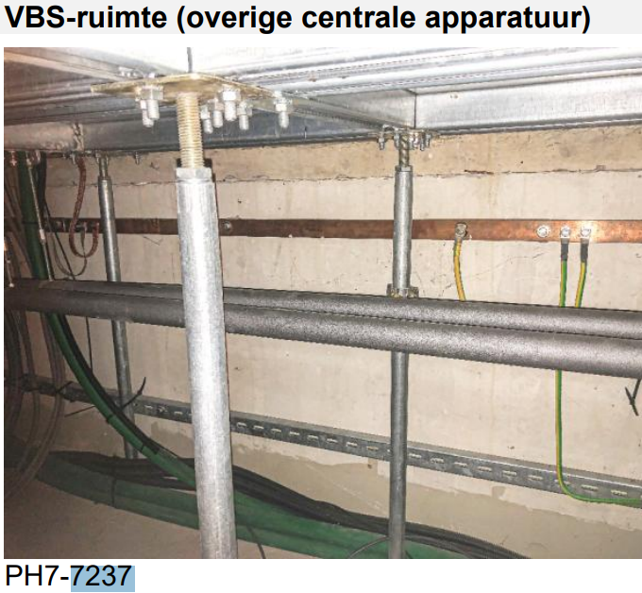
B1 – Takhuisje 3 | B2
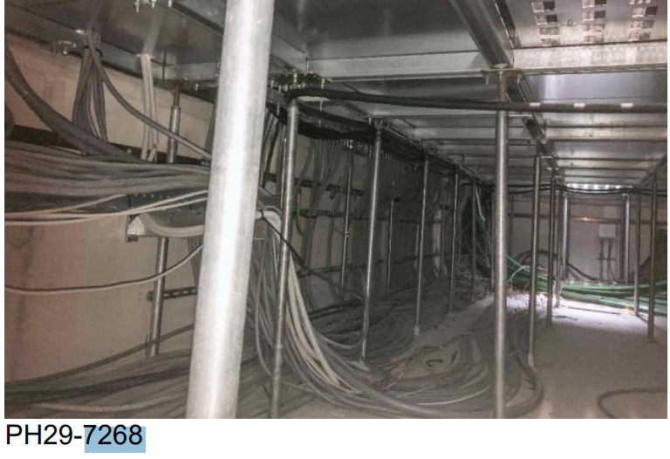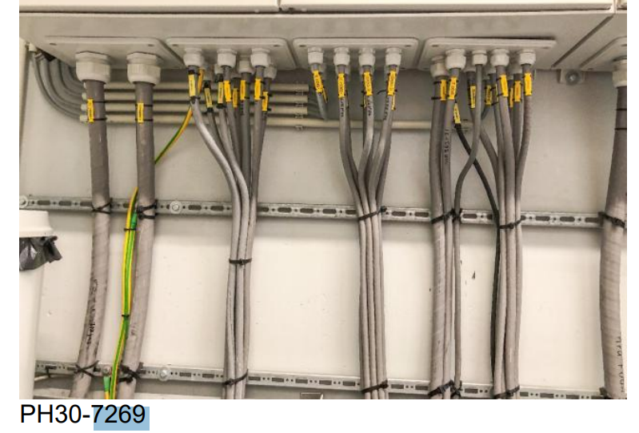 | No photo of mesh
B3 takhuisje 3
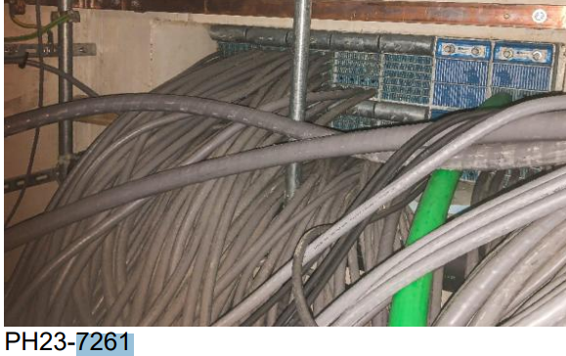
C2 - AIS earthing and steel structures | C3
 | Check fence
